Burnt Knoll and Mount Kelly Plots
Plot Numbers: 00NCe73 (completed), 00NCe74, 00NCe75, 00NCe76, 00NCe93, 00NCe94, 00NCe95 (completed)
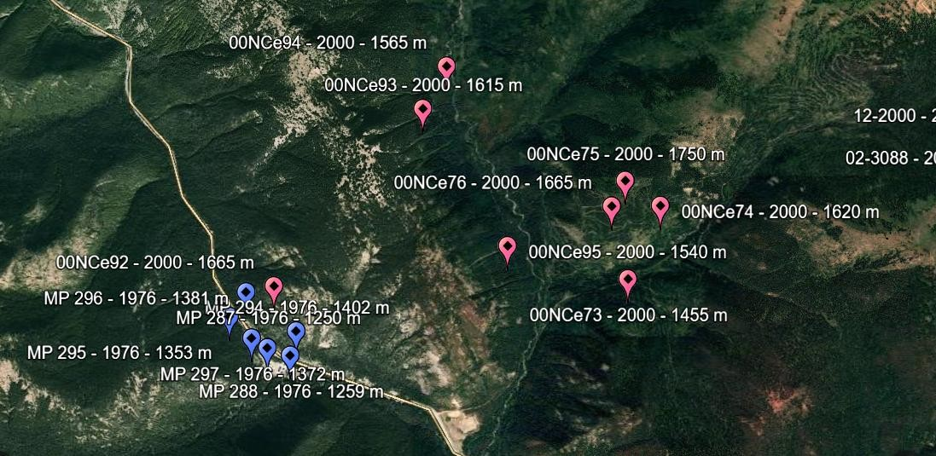

Dates | July 12-14, 2025
Location | Burnt Knoll and Mount Kelly area
Parking | Cambie Creek Trailhead Parking
Campground | Dispersed camping on Cambie Creek Loop trail  - Trail is not used nor maintained in the summer, so Rachel and I scoped out a campsite along the trail next to the river and bridge (waypoint was made on the Garmin)
Water Sources | Tons of creeks in the area and camp is set up next to the Similkameen River
Access to sites | Access from trailhead via HWY 3, Cambie Creek Loop Trial, Fat Dog Trail, Unnamed trails  - Access to Plots 00NCe73, 00NCe74, 00NCe75, 00NCe76:  - Hiking access: Cambie Creek Loop Trial then Fat Dog Trail  - Access to Plots 00NCe93, 00NCe94, 00NCe95:  - Hiking access: Cambie Creek Loop Trial then unnamed trail
Predicted Weather | As of July 4th: N/A
Special Precautions | - When Rachel and I were in the area, there was lots of bear scat on the trail, some fresher, some old. 2 cans of bear spray should be taken in case.
Packing List | - Will send out document later on
Tentative hourly plans for the weekend:
Saturday July 12th Evening Plan:
- 6:00 – 9:30 pm: Drive from Vancouver to Cambie Creek Winter Campsite, Manning Park
  - I’ll check with Amy, but we could take Casper if that is the best option for a vehicle
  - I will have picked up supplies and food for the weekend beforehand, so no need to stop for anything unless we want to save some cooking time with dinner on the road!
- 9:30 pm: Hike in from parking (1.45km, 59m elevation) and set up camp
Sunday July 13th Plan (busy day!):
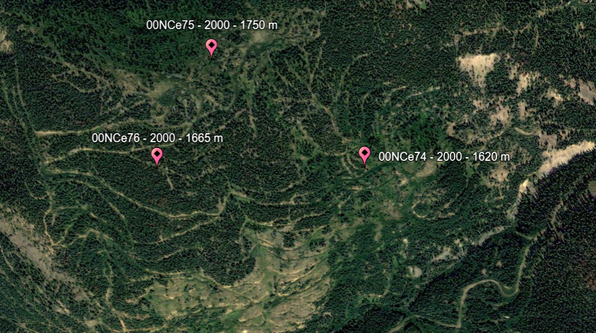
- 6:30 – 7:30: Wake up and breakfast
- 7:30 – 9:30: Hike 3.36km on Fat Dog Trail, 293 elevation gain (unless access to cross the creek is available at 1.95km – 2.95km)
- 9:30 – 10:30: Cross creek to unnamed trail, hike 1.13 km on unnamed trail, then bushwhack 200m to plot 00NCe74
- 10:30 – 1:30: Resurvey plot 00NCe74
- 1:30 – 2:00: Lunch
- 2:00 – 2:45: Bushwhack or take old logging roads to 00NCe75 (500m as the crow flies)
- 3:00 – 6:00: Resurvey 00NCe75
- (If time) Bushwhack down the mountain or take old logging roads to 00NCe76 (280m as the crow flies)
- (If time) Resurvey 00NCe76
- 6:00 – 8:00: Bushwhack 500m as the crow flies back to trail. Hike 1.13km E, cross the creek, then 3.36km back on Fat Dog Trail to camp
- 8:00: Back at camp for dinner and sleep!
Monday July 14th Plan:
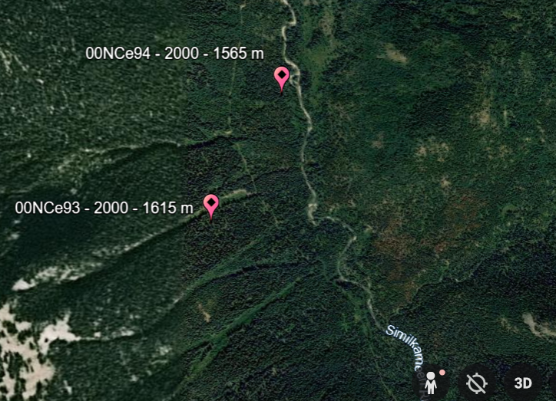
- 6:30 – 7:30: Wake up and breakfast
- 7:30 – 9:00: Hike 2.75 km, 200m elevation gain, along unnamed trail, then bushwhack 180m and 50m elevation gain to 00NCe93. Elevation listed is wrong for the lat/long coordinates given.
- 9:00 – 12:00: Resurvey 00NCe93
- 12:00 – 12:30: Lunch
- 12:30 – 1:00: Hike 600m on trail, then bushwhack 175m to 00NCe94
- 1:00 – 4:00: Resurvey 00NCe94
- 4:00 – 6:00: Hike back to camp
- 6:00: Dinner and hang by creek or take down camp and head home
  - I might stay depending on whether or not Amy is joining on the 15th

More Maps:
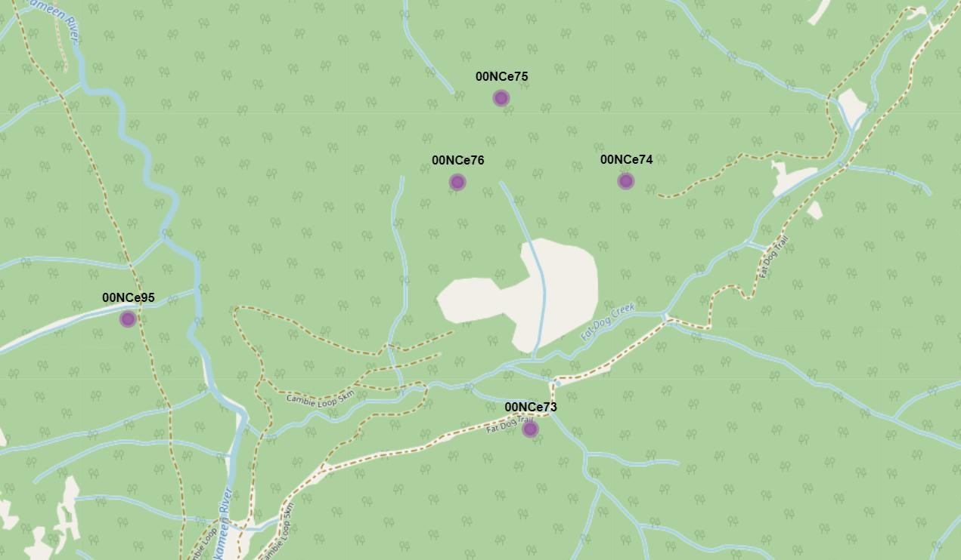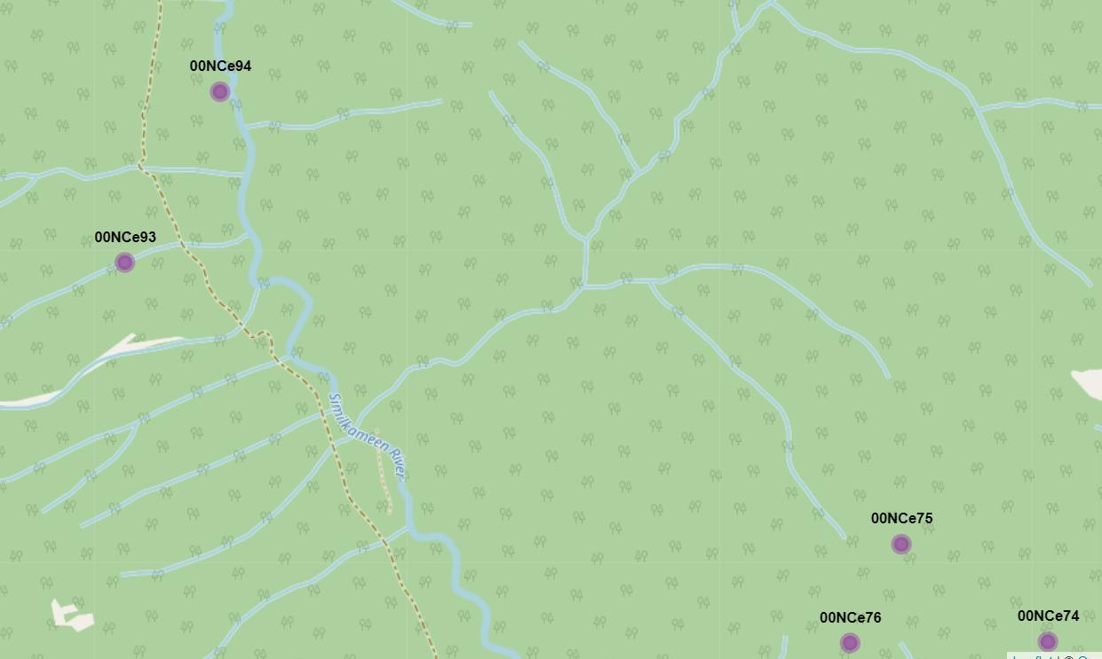

Plot Number | 00NCe73 **Completed on June 27th
Project ID | NCBG_ESSFplots
Date Surveyed | 2000-10-01
Access Via | Trail: Cambie Creek Loop to Fat Dog Trail  - Take the Cambie Creek Loop for ~1.7km, then yield right onto Fat Dog Trail for another ~2km (or until an easy access point to the sites is found - ~7.2 km out and back on the trail  Parking: Cambie Creek Trailhead Parking or pullout
Location | Longitude: -120.8200364  Latitude: 49.12286895  Elevation: 1455  Location Notes:  Cambie Creek (Fat Dog Creek) in Manning Provincial Park
Site Information: | Stand age: NA  Slope gradient: 56  Aspect: 353  Meso Slope Position: MD  Surface shape: ST  BEC Zone and Subzone: ESSF mw  Site notes:  "--EcoPoly: 12278, --FC: no typing available, --%canclosure: 50, 85, 90, 40= 66; this is a better estimate of the overall coverage of A layer and B1 layer coverage at the site), --very closed canopy forest, --S-M sized old herbaceous scat in plot"
Plot Representation | ESSFmw forested mesic mid-seral post-harvest
Species Recorded in original survey | Species list complete: FALSE  ABIELAS, ABIEAMA, TSUGHET, MENZFER, PICEENE, RUBUPED, PAXIMYR,  CORNCAN, RHYTIDIO, TIARTRI2, PLAGIOMN, VACCMEM
Veg Notes | NA
Soil Notes | NA

Plot Number | 00NCe74
Project ID | NCBG_ESSFplots
Date Surveyed | 2000-10-01
Access Via | Trail: Cambie Creek Loop to Fat Dog Trail  - Hike 3.36km, 300m elevation gain, along Fat Dog Trail (unless access to cross the creek is available at 1.95km – 2.95km)  - Hike 1.13km along unnamed trail (likely old logging trail) and 200m off trail to site
Location | Longitude: -120.8160951  Latitude: 49.12958668  Elevation: 1620  Location Notes:  Cambie Creek (Fat Dog Creek) in Manning Provincial Park
Site Information: | Stand age: NA  Slope gradient: 45  Aspect: 149  Meso Slope Position: UP  Surface shape: ST  BEC Zone and Subzone: ESSF mw Site notes:  "--EcoPoly: 11806, --FC: no typing available, --%canclosure: 0,0,5,10= 4, --fair amount of case-hardened CWD suggesting F.l.bb, --site has not restocked too well given that it is generally of the same vintage as the setting across the valley (essf73); it appears as if berries are best around the base of individual clumps of conifers (mainly lasiocarpa)""
Plot Representation | ESSFmw forested dry mid-seral post-harvest
Species Recorded in original survey | Species list complete: FALSE  HIERACIU, OSMOBER, ABIEAMA, SPIRLUC, ANAPMAR, LUPIARC, FRAGVIR, SALIX,  THALOCC, ALNUALN, RUBUPAR, VALESIT, RIBELAC, ASTER, ARNILAT, CLINUNI,  ABIELAS, POPUTRE, PAXIMYR, VACCSCO, PINUCON2, CHAMANG, RHODALB,

 | EQUISETU, RIBEACE, LONIUTA, CALACAN, VACCMEM
Veg Notes | "--very sparse mosses, --some really big trees were harvested from this site,-looks like quite a lot of dried-up white berries at this site (too much heat an sun causing failure; too dry?)"
Soil Notes | @very little humus present

Plot Number | 00NCe75
Project ID | NCBG_ESSFplots
Date Surveyed | 2000-10-01
Access Via | Trail: Cambie Creek Loop to Fat Dog Trail  - Bushwhack 500m, 125m elevation gain (as the crow flies), or take old logging roads from 00NCe74
Location | Longitude: -120.8212604  Latitude: 49.13184343  Elevation: 1750  Location Notes:  Cambie Creek (Fat Dog Creek) in Manning Provincial Park
Site Information: | Stand age: NA  Slope gradient: 18  Aspect: 53  Meso Slope Position: CR  Surface shape: CV  BEC Zone and Subzone: ESSF mw Site notes:  --EcoPoly: 11824, --FC: no typing available, -%canclosure: 0,0,10,0= 3 (A layers), possibly parkland,--lots of CWD of variable piece sizes (slash)
Plot Representation | ESSFmw forested mesic mid-seral post-harvest
Species Recorded in original survey | Species list complete: FALSE  POACEAE_, SORBSIT, PICEENE, VALESIT, ASTER, ABIELAS, RIBEACE, VACCMEM, PAXIMYR, RHODALB, VACCSCO, HIERACIU, LUPIARC, CHAMANG, RUBUPED, CERAPUR
Veg Notes | NA
Soil Notes | NA

Plot Number | 00NCe76
Project ID | NCBG_ESSFplots
Date Surveyed | 2000-10-01
Access Via | Trail: Cambie Creek Loop to Fat Dog Trail  - Bushwhack 280m, 40m elevation decrease (as the crow flies), or take old logging roads from 00NCe75
Location | Longitude: -120.8230328  Latitude: 49.13184343  Elevation: 1665  Location Notes:  Cambie Creek (Fat Dog Creek) in Manning Provincial Park
Site Information: | Stand age: NA  Slope gradient: 58  Aspect: 209  Meso Slope Position: MD  Surface shape: ST  BEC Zone and Subzone: ESSF mw Site notes:  "--EcoPoly: 11806, --FC: no typing available, --%canclosure: 15,15,20,25= 24; capturing overstory A1/A2, --lots of CWD!!, --I suspect, but can't confirm, that this site was subjected to a bug attack at some point in the past b/c of lot of CWD on ground and snags in the canopy, --site has two distinct layers which would seem to point towards some sort of dist hx--but not much evidence of fire however"
Plot Representation | ESSFmw forested dry mid-seral
Species Recorded in original survey | Species list complete: FALSE  PICEENE, PINUCON2, ABIELAS, VALESIT, HIERACIU, PAXIMYR, ORTHSEC,  VACCMEM, RHYTROB, GOODOBL, RHODALB, RUBULAS
Veg Notes | --B2 and C layers very shaded by thick A (A3 in particular) and B1 layers

Plot Number | 00NCe93
Project ID | NCBG_ESSFplots
Date Surveyed | 2000-10-06
Access Via | Trail: Cambie Creek Loop to Unnamed Trail  - Hike 2.75 km, 200m elevation gain, along unnamed trail, then bushwhack 180m and 50m elevation gain to 00NCe93. Elevation listed is wrong for the lat/long coordinates given.
Location | Longitude: -120.8485222  Latitude: 49.13832844  Elevation: 1615  Location Notes:  Manning Park, in the upper Similkameen River upstream of Fat Dog Cr.
Site Information: | Stand age: NA  Slope gradient: 38  Aspect: 78  Meso Slope Position: LW  Surface shape: CC  BEC Zone and Subzone: ESSF mw Site notes:  "--EcoPoly: 11756, --FC: no typing available, --%canclosure= 0, --multiple smal micro AvTrs throughout the NE aspect of these ridgelines, quite steep in places with abundant gullies; likely fairly frequent slides which maintain this type of vegetation structure; plot is located in the run-out zone at the base of the path, -lots of blown/knocked down stems from past events"
Plot Representation | ESSFmw non-forested avalanche tracks seral coniferous forest
Species Recorded in original survey | Species list complete: FALSE  RUBUPED, PICEENE, VALESIT, VERAVIR, CHAMANG, SAMBRAC, CIRSIUM,  PECTBRE, RIBELAC, VACCMEM, LUPIARC, HERAMAX, POACEAE_, RIBEACE,  SORBSIT, ANAPMAR, GALIAPA, ABIELAS, HIERACIU
Veg Notes | --mosses present in specific micro-sites, not continous cover; no spp specific id's

Plot Number | 00NCe94
Project ID | NCBG_ESSFplots
Date Surveyed | 2000-10-06
Access Via | Trail: Cambie Creek Loop to Unnamed Trail  - Begin on the Cambie Creek Loop trail and continue to veer left at all trails. Trail to 00NCe93-95 is unnamed on maps but goes behind Mount Kelly on the NE side. ~9 km out and back on the trail  Parking: Cambie Creek Trailhead Parking or pullout
Location | Longitude: -120.8451718  Latitude: 49.1422333  Elevation: 1565  Location Notes:  Manning Park, upper Similkameen River upstream of Fat Dog Cr in old burn
Site Information: | Stand age: NA  Slope gradient: 30  Aspect: 97  Meso Slope Position: TO  Surface shape: CV  BEC Zone and Subzone: ESSF mw Site notes:  "--EcoPoly: 11620, --FC: no typing available, --%canclosure: 20, 25, 20, 45= 28, -the site is definately post-disturbance but not quite as mid-seral as I had hoped; structurally, it's quite MF feeling and not that closed canopy; canopy height is just a lot lower than at maturity,--fire hardened CWD slowly decomposinng throughout the habitat type-~10% cover overall "
Plot Representation | ESSFmw forested mesic mid-seral post-fire
Species Recorded in original survey | Species list complete: FALSE  VACCSCO, LONIUTA, LUPIARC, GOODOBL, PICEENE, ABIELAS, VACCMEM,  ORTHSEC, PAXIMYR, LONIINV, SYMPFOL, SALIX, VALESIT, ABIEAMA, RUBUPED, PINUCON2, RIBEACE, RHODALB, VACCSCO
Veg Notes | --obviously, other moss species present; continuous cover throughout habitat type
Plot Number | 00NCe95 **Completed on June 27th
Project ID | NCBG_ESSFplots
Date Surveyed | 2000-10-06
Access Via | Trail: Cambie Creek Loop to Unnamed Trail  - Begin on the Cambie Creek Loop trail and continue to veer left at all trails. Trail to 00NCe93-95 is unnamed on maps but goes behind Mount Kelly on the NE side. ~9 km out and back on the trail  Parking: Cambie Creek Trailhead Parking or pullout
Location | Longitude: -120.8366702  Latitude: 49.12585389  Elevation: 1540  Location Notes:  Manning Park, upper Similkameen River, close to Fat Dog confluence
Site Information: | Stand age: NA  Slope gradient: 45  Aspect: 74  Meso Slope Position: MD  Surface shape: ST  BEC Zone and Subzone: ESSF mw Site notes:  "--EcoPoly: 11755, --FC: no typing available, --%canclosure: 55,50,60,45= 53, -lots of small piece size CWD-self thinning in action-~15% cover in total,"
Plot Representation | ESSFmw forested mesic mid-seral
Species Recorded in original survey | Species list complete: FALSE  TIARTRI2, ABIEAMA, SPIRLUC, RHYTROB, CORNCAN, GOODOBL, VALESIT,  LONIUTA, PYROASA, RUBUPED, CHIMUMB, VACCMEM, PICEENE, PAXIMYR
Veg Notes | =--@moss cover is quite continuous

